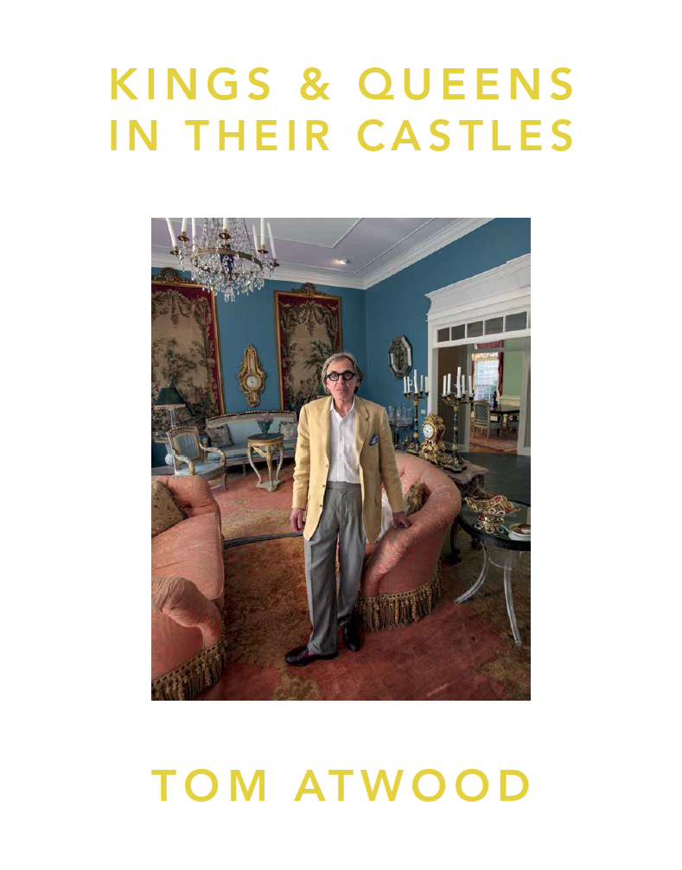

KINGS & QUEENS

IN THEIR CASTLES

Photography Book by Tom Atwood

Featuring about 60 celebrities.

Called the most ambitious photo series ever
conducted of the LGBTQ experience in the USA.

Preview at: http://www.tomatwood.com/kings-queens

Long Description
Kings & Queens in Their Castles has been called the most ambitious photo series ever conducted of the LGBTQ experience in the USA. Over 15 years, Atwood photographed more than 350 subjects at home nationwide (with over 160 in the book), including nearly 100 celebrities (with about 60 in the book). With individuals from 30 states, Atwood offers a window into the lives and homes of some of America's most intriguing and eccentric personalities.

Among the luminaries depicted are Meredith Baxter, Alan Cumming, Don Lemon, John Waters, George Takei, Alison Bechdel, Barney Frank, Don Bachardy, Billy Porter, Ari Shapiro, Arthur Tress, Michael Urie, Greg Louganis, Charles Busch, Kate Clinton, Dan Savage, Tommy Tune, Jonathan Adler, Simon Doonan, Leslie Jordan, Anthony Rapp, John Berendt, Bruce Vilanch, John Corigliano, Anthony Goicolea, Elizabeth Streb, Michael Musto, Carson Kressley, Joel Schumacher, Christian Siriano, John Ashbery, Terrence McNally and Christine Vachon.

Modern day tableaux vivants, the images portray whimsical, intimate moments of daily life that shift between the pictorial and the theatrical. Alongside creatives such as artists, fashion designers, writers, actors, directors, music makers and dancers, the series features business leaders, politicians, journalists, activists and religious leaders. It includes those who keep civilization running, such as farmers, beekeepers, doctors, chefs, bartenders and innkeepers. Some miscellaneous athletes, students, professors, drag queens and socialites. As well as a cartoonist, barista, poet, comedian, navy technician, paleontologist and transgender cop. Also showcased are urban bohemians, beatniks, mavericks and iconoclasts, many of whom blossomed in the 1960s and 1970s but seem to be slowly disappearing.

Medium Description
Kings & Queens in Their Castles has been called the most ambitious photo series ever conducted of the LGBTQ experience in the USA. Over 15 years, Atwood photographed more than 350 subjects at home nationwide (with over 160 in the book), including nearly 100 celebrities (with about 60 in the book). With individuals from 30 states, Atwood offers a window into the lives and homes of some of America's most intriguing and eccentric personalities.

Among the luminaries depicted are Meredith Baxter, Alan Cumming, Don Lemon, John Waters, George Takei, Alison Bechdel, Barney Frank, Don Bachardy, Billy Porter, Ari Shapiro, Arthur Tress, Michael Urie, Greg Louganis, Tommy Tune, Jonathan Adler and Terrence McNally.

Modern day tableaux vivants, the images portray whimsical, intimate moments of daily life that shift between the pictorial and the theatrical. Fine art photos rich in beauty and clarity, these personal landscapes are both a witness and a celebration.

Short Description
Kings & Queens in Their Castles has been called the most ambitious photo series ever conducted of the LGBTQ experience in the USA. Over 15 years, Atwood photographed more than 350 subjects at home nationwide (with over 160 in the book), including nearly 100 celebrities (with about 60 in the book). Among the luminaries depicted are Meredith Baxter, Alan Cumming, Don Lemon, John Waters, George Takei, Alison Bechdel, Barney Frank, Don Bachardy, Billy Porter, Ari Shapiro, Arthur Tress, Michael Urie, Greg Louganis, Tommy Tune, Jonathan Adler and Terrence McNally. Modern day tableaux vivants, the images portray whimsical, intimate moments of daily life that shift between the pictorial and the theatrical.

SUBJECTS

Meredith Baxter – Actress from Family Ties, All the President's Men, Glee, Family
Alan Cumming – Tony-winning actor from Hamlet, Macbeth, Cabaret
Don Lemon – CNN Anchor
George Takei – Actor from Star Trek, The Twilight Zone, Star Wars, Heroes
Barney Frank – Former US Congressman and chair of Financial Services Committee
Greg Louganis – Olympic diver and gold medal winner
Michael Urie – Actor from Ugly Betty, The Good Wife, Partners, Modern Family
Terrence McNally – Tony and Emmy-winning writer and playwright
Ari Shapiro – Co-host of NPR's All Things Considered
Kate Clinton – Comedian and actress from The L Word
John Waters – Director of Pink Flamingos, Polyester, Hairspray, Pecker, Serial Mom
Don Bachardy – Acclaimed artist and former partner of Christopher Isherwood
Tommy Tune – Ten time Tony-winning performer and National Medal of Arts winner
Alison Bechdel – Cartoonist, MacArthur Genius Grant winner and author of Fun Home
Jonathan Adler – Designer and homeware magnate
Elizabeth Streb – Acclaimed choreographer
Rufus Wainwright – Award-winning singer and songwriter
Julie Mehretu and Jessica Rankin – Renowned artists
Joel Schumacher – Director of Phantom of the Opera, Batman & Robin, St. Elmo’s Fire
Bruce Vilanch – Emmy-winning celebrity from Hollywood Squares
Arthur Tress – Renowned photographer
Mark Takano – US Congressman
Leslie Jordan – Actor from The Help, Sordid Lives, Will & Grace, Boston Legal, Newhart
Neda Ulaby – NPR arts correspondent
Billy Porter – Tony-winning actor from Kinky Boots, Jesus Christ Superstar
Jim McGreevey – Former New Jersey Governor
Randal Kleiser – Director of Grease, Grandview U.S.A., Big Top Pee-wee, The Blue Lagoon
John Berendt – Author of Midnight in the Garden of Good and Evil, The City of Falling Angels
Christine Vachon – Producer of Still Alice, Boys Don't Cry, Far from Heaven, I Shot Andy Warhol
John Corigliano – Grammy and Pulitzer-winning composer
Anthony Rapp – Actor from Rent, Dazed and Confused, Psych, The X-Files, A Beautiful Mind
Charles Busch – Playwright and author of Tale of the Allergist's Wife, Vampire Lesbians of Sodom
Heather Matarazzo – Actress from The Princess Diaries, Sisters, ER, Strangers with Candy
Dan Savage – Columnist and media pundit
Simon Doonan – Television personality and Barneys NY creative director
Michael Musto – Village Voice columnist and television personality
Felice Picano – Author of Nights at Rizzoli, Art & Sex in Greenwich Village
Carson Kressley – Bravo and OWN television host
Steve Kmetko – CBS reporter and E! Entertainment anchor
Christian Siriano – Project Runway winner
Annise Parker– Houston Mayor
Madison Hildebrand – Star of Million Dollar Listing
Bishop Gene Robinson – First out gay bishop
Ria Pell – Chef from Top Chef and winner of Chopped
Anthony Goicolea – Artist
David Moretti – Actor from House of Cards, The Lair, Scrooge & Marley, Arizona
Mark Adamo – Acclaimed opera composer
Doug Spearman – Actor from Charmed, Star Trek Voyager, Noah's Arc, Girlfriends
Jay McCarroll – Project Runway winner
Neil Giuliano – Former Tempe Mayor and president of GLAAD
Marc Anthony Samuel – Actor from Imperfect Sky, Avenged, Parenthood
Laura Flanders – Journalist and Air America Radio host
Darryl Stephens – Actor from Undressed, Noah's Arc, Desperate Housewives
Frank Marino – Longest-running headliner on the Strip, dubbed "Ms. Las Vegas"
Christopher Rice – Author of six bestselling novels and co-host of The Dinner Party Show
Martyn Lawrence-Bullard – Star of Million Dollar Decorators, Hollywood Me
Erin McKeown – Award-winning singer
George Kotsiopoulos – Co-host of Fashion Police and correspondent for MSNBC
Jess Cagle – Editorial director of People Magazine and Entertainment Weekly
Arnold Myint – Drag performer and chef from Top Chef
Bruce Cohen – Producer of American Beauty, The Nines, Big Fish, The Forgotten, Milk
Josh Flagg – Star of Million Dollar Listing
John Ashbery – Pulitzer-winning Poet Laureate of New York
And many others

REVIEWS

"Atwood's work is at once evocative of both early European master paintings and old Hollywood cinematography. Atwood meticulously composes each image to convey that we and our homes are a unified fabric."
– Yossi Milo, Yossi Milo Gallery

"Atwood presents a unique and refreshing spin on environmental portraiture – pictures alive with imagination, detail and beauty. He turns his gaze to some of the most creative and influential cultural leaders of our time... Atwood’s camera – and his eye – makes the medium seem fresh, alive and attention-grabbing."
– Annie Philbin, Director of Hammer Museum

"The access Tom Atwood tirelessly worked to achieve is absolutely astonishing. With charm, pizzazz, and sheer determination, Atwood captures the intimate lives of many of the most fascinating and respected members of our LGBTQ community. Bravo!"
– Brian Clamp, ClampArt

“Marvelous photographs that capture our idiosyncrasies and obsessions.”
– Tony Kushner, Playwright

"A work of immense depth and richness, like a monumental series of biographies.”
– Andrew Lear, Harvard University

"With acute sensitivity and striking visual flair, Atwood penetrates secret lairs... resulting in brilliantly-constructed stages displaying uninhibited flights of imaginative fantasy."
– Arthur Tress, Photographer

"An outstanding achievement in environmental portraiture. Atwood portrays his subjects with passion and grace, giving royal treatment to both the glamorous and the chaotic."
– Moisés Kaufman, Playwright

PRESS RELEASE

(to be written)

ARTIST’S STATEMENT

By Tom Atwood

Kings & Queens in Their Castles is an extensive photography series exploring the LGBTQ experience in the USA. Over 15 years, I photographed more than 350 subjects at home nationwide (with over 160 in the book), including nearly 100 luminaries (with about 60 in the book). With individuals from 30 states, the series offers a window into the lives and homes of some of America's most intriguing and eccentric personalities.

The title, in addition to paying tribute to our dazzling drag kings and queens, is a nod to aristocracy from history reputed to have engaged in alternative sexuality or gender practices or sensibilities. Among these are Japanese samurai knights, Roman emperor Hadrian, French kings Henri III and Louis XIII, Alexander the Great, England's King Edward II, King James I of England and Scotland, Queen Christina of Sweden, Prince Eugene of Savoy and King Ludwig II of Bavaria. Not to mention King Frederick II of Prussia, with his Sanssouci palace adorned with gay-themed antiques.

I decided to photograph LGBTQ Americans because I felt there was a need for a contemplative photo series of the community. Many LGBTQ series depict scantily-clothed young subjects romping through the forest or lounging on the beach. There was a need for a series highlighting our manifold personalities and backgrounds. And I wanted to create a body of work that would strengthen the identity of and be a source of pride for the LGBTQ community, as well as feature role models.

Today, in terms of the modern civil rights movement, it's helpful to highlight that LGBTQ folks are in many ways like everyone else, and as diverse as society as a whole. Yet on another level, there is a common LGBTQ sensibility that sets us apart that I wanted to recognize and celebrate. This sensibility shares an outlook with the sensibility of creative and cultural leaders—an awareness of difference, of other, of possibility—an avant-garde mindset. One fascinating phenomenon my series explores is just how many creative and cultural leaders are LGBTQ. We may be disproportionately represented in the arts, culture and entertainment.

This seems as true now as it may have been throughout history. Homosexuality or a gay sensibility appears in art from virtually every culture and time period—from ancient Peruvian ceramics to nearly all Greek art forms to fourteenth century Japanese art. Moreover, examples of LGBTQ individuals excelling in art and culture abound. From Native American berdaches, with their exceptional aptitude for crafts, to da Vinci, Michelangelo, Cadmus, Warhol, Rauschenberg and Hockney. From writers such as Sappho, Oscar Wilde and Gertrude Stein. To architects such as Philip Johnson. Actors such as Rock Hudson and Jodie Foster. Journalists such as Don Lemon, Anderson Cooper and Rachel Maddow. Fashion designers such as Yves Saint Laurent and Tom Ford. And of course, photographers such as Bernice Abbott, Minor White, Horst, Mapplethorpe, Leibovitz, LaChapelle and Opie. Alternative sexuality or gender practices and extraordinary talent in arts and culture often seem to be intertwined.

So the assemblage of LGBTQ creative and cultural leaders in my book should come as no surprise. Some viewers may love photographs of celebrities and some may find them tiresome. Personally, I find high profile subjects and everyday individuals equally interesting. Yet I can understand why many people are particularly drawn to celebrity photographs—we already have a history with many of these subjects. If we loved an actor's movie or a writer's book, it would only be natural to want to know more about their lives.

My photographic style has a hint of camp, a conscious choice in celebration of—as Susan Sontag pointed out—the intersection of a gay sensibility and camp. As a photography and art history autodidact, most of my style and technique I developed through trial and error. My approach evolved organically over time, as a confluence of related interests in psychology, theater, architecture, urban planning and drawing. It's been influenced primarily by my life experiences and by the everyday world around me.

I attempt to distinguish Kings & Queens in Their Castles from other portrait series in a number of aspects. My approach is a blend of portraiture and architectural photography, to illustrate that subjects and environments are a unified fabric. I shoot subjects at home because our natural habitats bring out our character. The LGBTQ person’s home is an extension of him/herself. And for a community sometimes obsessed with image and beauty, our living spaces can also be the ultimate in self-expression. With a flair for design, many of these subjects have crafted playful, often outlandish homes that tell stories about their inhabitants.

I use a wide-angle lens and wide depth of field so that neither subject nor home predominates. Conventional portraiture, on the other hand, tends to emphasize the person, through backgrounds of streamlined simplicity often with a narrow depth of field. I often seek out backdrops and angles packed wall-to-wall with idiosyncratic belongings, paraphernalia and detail, albeit balanced by sweeping exterior shots. Making use of the full color palate, I attempt to uncover what such homes reveal about how multifarious LGBTQ personalities can be.

To fully create 360-degree portraits, I photograph people in daily activity—modern day tableaux vivants. I seek out whimsical, intimate moments of everyday life that shift between the pictorial and the theatrical. While the images often have an element of voyeurism, my subjects occasionally look at the camera as in reality, when being photographed subjects are typically aware of a photographer's presence. I strive for the images to look naturally lit by ambient light, yet most shots are lit with a mixture of tungsten and strobe lights. Almost all shots are hand held (no tripod) and almost all are 35mm digital (although my first book, Kings in Their Castles, was mostly film).

I found subjects through thousands of hours of research, letter writing, phone calls, networking, and posting requests on public message boards and social media groups. The subjects in the series are by no means a representative social, economic or ethnic cross section of LGBTQ America. Yet a broad spectrum of geographies and professions are represented. Alongside creatives such as artists, fashion designers, writers, actors, directors, music makers and dancers, I feature business leaders, politicians, journalists, activists and religious leaders. I include those who keep our country running, such as farmers, beekeepers, police officers, doctors, chefs, bartenders and innkeepers. I exhibit some miscellaneous athletes, students, professors, drag queens and socialites. As well as a cartoonist, barista, poet, comedian, navy technician and paleontologist. I also showcase urban bohemians, beatniks, mavericks and iconoclasts, many of whom blossomed in the 1960s and 1970s but seem to be slowly disappearing. It should be noted that a few people in the series are straight friends who happened to be visiting subjects when I was shooting.

Ultimately, I record the personal landscapes of these subjects for them to become works of art in their own right. With elements of both formal portraiture and informal snapshots, my images attempt to dance the line between beauty and chaos, sometimes simultaneously comforting and unsettling. I hope that you find the sum of these photographs inspiring and moving and that they arouse in you as much delight and curiosity as they do in me. I invite you to view dozens more photographs at www.TomAtwood.com.

TARGET MARKETS

Art & Photography Enthusiasts
Kings & Queens in Their Castles should attract considerable attention in the art and photography community as it is promoted through galleries/exhibitions and competitions.

Celebrity & Pop Culture Enthusiasts
A book with high profile subjects will appeal to followers of those subjects.

Architecture & Design Buffs
The extraordinary architecture, interiors, decorations and fashions illustrated in the book should inspire and excite design enthusiasts. The book stands out from typical design books by including the whole package – people and where and how they live.

LGBTQ Individuals & Allies
The book should appeal to both LGBTQ and straight individuals alike.

BIOGRAPHY

Long Biography
Tom Atwood
Tom Atwood's recent work has focused on portraits of people at home. He has shot over 100 luminaries including Hilary Swank, Julie Newmar, Buzz Aldrin, Don Lemon, Meredith Baxter, George Takei, Alison Bechdel, Alan Cumming, Edward Albee, Andrew Solomon, Todd Oldham, Edmund White, Ned Rorem, Michael Cunningham and Ross Bleckner.

Atwood won Photographer of the Year from London's Worldwide Photography Gala Awards, as well as first place in Portraiture, chosen from over 3,000 entries from about 50 countries. He also won first place in Portraiture in the Prix de la Photographie Paris competition, chosen from thousands of entries from over 85 countries.

He has won over 30 additional awards including from the Griffin Museum of Photography, Center for Fine Art Photography, International Photography Awards, Image International, Santa Fe Center for Photography, Manhattan Arts International, World in Focus, Artrom Gallery Guild (Rome), Kodak, Fence at Photoville, CameraArts Magazine, Photo Life Magazine, PDN, Photographer's Forum Magazine, Photo Review, Applied Arts, Communication Arts, Graphis, American Photography Annual, One Life, American Art Awards, Photography Masters Cup, One Eyeland, Jacob Riis Award, IPOTY, Camera Club of NY, International Color Awards, Moscow International Foto Awards and APA.

Atwood's work has exhibited at the Museum of Photographic Arts, George Eastman Museum, Griffin Museum of Photography, Center for Fine Art Photography, Círculo de Bellas Artes (Madrid), LA Center for Digital Art, Pacific Design Center and Directors Guild of America. His work has exhibited at various art fairs such as Photo LA, as well as at several galleries, most recently ClampArt in NY, Steven Kasher Gallery in NY, Louis Stern Fine Arts in LA, Farmani Gallery in LA and PDNB Gallery in Dallas.

His work has been featured in over 150 publications in over a dozen countries including The New York Times, Los Angeles Times, San Francisco Chronicle, Washington Post, New Yorker, Los Angeles Magazine, Elle, Huffington Post, Harvard Magazine, Art Newspaper, Artforum, Art Ltd., Applied Arts, Photo Life, Photo Selection, Photo Review, PDN and Popular Photography. Atwood has also appeared on Sirius, CBS, Bravo, Telemundo and other networks.

He has shot photography for a variety of corporate clients, from Disney to BMW, Lexus and CAA, as well as editorial clients, from The Wall Street Journal to Brandweek and Angeleno.

Atwood has a Bachelors from Harvard University and a Masters from Cambridge University (England). He has lectured on photography at various organizations and universities including UCLA and the School of Visual Arts, has been a juror for London's Worldwide Photography Gala Awards and was a portfolio reviewer for Popular Photography and American Photo. In a past life, he also served as a Director at several global advertising agencies including Ogilvy & Mather, McCann and DDB. Based in New York, Atwood has lived in Los Angeles, San Francisco, Boston, Amsterdam and Paris. He grew up on a dirt road in the woods of Vermont. Learn more and view dozens of additional photographs at www.TomAtwood.com.

Medium Biography
Tom Atwood
Tom Atwood has shot over 100 luminaries such as Hilary Swank, Buzz Aldrin and John Waters. He won Photographer of the Year from London's Worldwide Photography Gala Awards, first place in Portraiture in the Prix de la Photographie Paris and has won over 30 other awards. Atwood's work has exhibited at the Museum of Photographic Arts, the George Eastman Museum, the Center for Fine Art Photography and several other institutions. His work exhibits at various galleries, most recently ClampArt, Steven Kasher, Louis Stern and PDNB. Atwood's work has been featured in over 150 publications including The New York Times, Los Angeles Times, New Yorker, Art Newspaper, Elle and PDN. And he has appeared on Sirius, CBS and other networks. Atwood has a Bachelors from Harvard and a Masters from Cambridge (England).

Short Biography
Tom Atwood
Tom Atwood has shot over 100 luminaries such as Hilary Swank, Buzz Aldrin and John Waters. He won Photographer of the Year from London's Worldwide Photography Gala Awards, first place in Portraiture in the Prix de la Photographie Paris and has won over 30 other awards. His work exhibits at various museums and galleries, most recently ClampArt, Steven Kasher, Louis Stern and PDNB, and has been featured in over 150 publications. Atwood has a Bachelors from Harvard and a Masters from Cambridge (England).

INFO

Book Title: Kings & Queens in Their Castles

Author: Tom Atwood

Publisher: Damiani (Italy)

Distributor: DAP (Distributed Art Publishers, http://www.artbook.com/dap.html)

Publication Date: March 17, 2017

ISBN: 978-88-6208-516-8

Large Book: 144 pages, 135 color images

Large Dimensions: 9 ¾ x 12 ½ inches, 24.8 x 31.8 cm

Special Features: Hardbound with gold hot-stamping of cover text, gold metallic endpapers

Price: $45, £35

Preview at: http://www.tomatwood.com/kings-queens

- Please mention at the end of the article/segment ‘for more on Atwood’s work, visit www.TomAtwood.com’.
- Please do not significantly crop any photos as how they are cropped is part of the artistic process.
- Thank you! Don’t hesitate to contact Tom directly with any questions: Tom@TomAtwood.com

